Meet Coach King
Welcome to another great year of Physical Education at Dallas Elementary! I am excited to start a new year full of many fun games, sports, and activities. This is my 10th year teaching and my third year at Dallas! I graduated with my undergraduate and masters playing softball for Jacksonville State University!
I am married to my wonderful husband Cody, and we both love running and competing in obstacle course racing. We also love road biking, hiking, and traveling. We don’t have any children; however, we have four dogs we love dearly!
I played Division one softball on a full ride scholarship to JSU. I also am a Battlefrog Endurance World Champ (Obstacle Course Race).
Excuse Notes
A student MUST bring a written note from his/her parent or guardian to be excused from my PE class. Please make sure to include: type of illness/injury, how long your child needs to be excused, and/or doctors notes or concerns (if applicable). Students are allowed only 3 notes per semester. A doctor’s note IS REQIRED for your child to miss more than a week of PE.
PLEASE SEE OTHER SIDE FOR MORE INFO!
Welcome to Coach King’s
Bulldog Physical Fitness Class!
We Work Hard, Play Hard, and Have Fun!

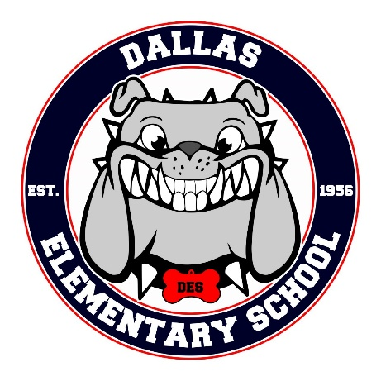
______

Safe Shoes
Please make sure your child checks his/her “specials” schedule weekly so that they can come prepared with proper shoes and clothing for PE. For safety reasons, any child who does not have the proper shoes will be walking on the side of the gym during the class period instead of running and playing. It is school policy that students wear TENNIS SHOES to PE. Proper shoe attire includes: Tennis shoes, sneakers with a flat bottom (no heels), and the foot fully covered. It is a good idea to send tennis shoes in your child’s backpack if you are unsure of their schedule. If your child wears a dress/skirt on PE day, shorts MUST be worn under the dress for PE.
Grading Policy
It is very important for your child to wear tennis shoes and participate each time he/she has Physical Education. Failure to do so will impact your child’s grade. Notes will be sent home EACH time your child misses PE due to behavior or improper attire. PLEASE SIGN AND RETURN THESE FORMS TO SCHOOL. 0-3 times note sent home=S; 4-5 times note sent home=N; 6+ times note sent home=U.

CONTACT INFORMATION: PE rules are in place to ensure a safe and
Cmking@paulding.k12.ga.us manageable classroom environment where
(770) 443-8018 learning can occur and to ensure students are ------------------------------------------------ growing to the best versions of themselves!

PE Rules/ Expectations:
First and foremost, students are expected to take responsibility for their actions. We, even as adults, all make mistakes, but part of maturing is admitting we made a mistake and learning from them. Our gym rules are as follows:
*Be RESPECTFUL! Show respect to yourself, other classmates, and the teacher. Speak in a respectful tone. This also includes showing nonverbal respect. For example: Rolling eyes, laying down during PE, etc.
* Follow Directions
*Show Great Sportsmanship
*Respect PE equipment and Gym
*Have fun and try your BEST! You don’t have to be the best, but you must try your best and participate!

To ensure the health and safety of your child, please fill out the form below with any health problems your child may have. Please return this to school as soon as possible. Thanks, and I look forward to a great year!
____ My child has no known health problems
------ My child has the following health problems
---------------------------------------------------------------------------------------------------------------------------
---------------------------------------------------------------------------------------------------------------------------
I have read and understand the PE policies and procedures: Date: ____________ Homeroom: _____________
Childs Name: ____________ Your Name (print): _________________ Signature: ___________________
I prefer to be contacted by:
_____ Phone ( ) - or ( ) - Text ___
_____ Email _____________________@_________________ Class Dojo _____

Discipline Procedures:
Students will review the PE rules and procedures at the beginning of each year. Students who do not follow directions/rules will be giving a verbal warning. Failure to follow rules again will result in a time out/cool down period. If students fail to follow directions for the third time, students will be given a permanent time out and a note will be sent home. This note is expected to be signed and returned. Severe circumstances may result in immediate time out/notes home. Students are expected to take responsibility for their behavior notes, get them signed by a parent/guardian, and return them to school by the next PE class. If students do not return PE behavior notes, they will not be able to participate in activities and parent contact will be made! PLEASE SIGN AND RETURN ALL PARENT NOTES!!

